OBSERVATION RECORD
Experiment No. 3
Car Booking Reservation System using Zoho Creator (SaaS)

Aim
To develop a cloud-based Car Booking Reservation System using Zoho Creator to demonstrate Software as a Service (SaaS) for booking cabs and maintaining booking records.

Problem Statement
Create a simple cloud software application for Car Booking Reservation System using any cloud service provider with fields such as search for cabs, from, to, rental, outstation, package type, hours/days, etc.

Objective
• Design an online cab booking form.
• Store customer and travel details in the cloud.
• Display booking records using reports.
• Demonstrate SaaS using Zoho Creator.

Software Requirements
• Zoho Creator
• Deluge (optional workflow)
• Web Browser
• Internet Connection

Theory
Zoho Creator is a cloud-based low-code platform used to develop SaaS applications. The Car Booking Reservation System enables users to search and reserve cabs, store booking details in the cloud, and generate reports for easy management.

Fields Used
Passenger Name, Employee ID, Email ID, Mobile Number, Gender, Booking Date, Travel Date, Pickup Time, Pickup Address, Destination Address, Cab Type, Trip Type (Rental/Outstation), Package Type, Hours/Days.

Algorithm
1. Start
2. Open the booking form.
3. Enter passenger and travel details.
4. Select trip type and package.
5. Submit the booking.
6. Store data in the cloud database.
7. Display all bookings in the report.
8. Stop.

Procedure
1. Login to Zoho Creator.
2. Create a new Car Booking application.
3. Design the booking form with all required fields.
4. Save the form and enter sample booking details.
5. Create a report to display all bookings.
6. Verify the stored records.

Observation
• The application accepted all booking details successfully.
• Records were stored in the cloud database.
• The booking report displayed all records.
• Individual booking details were viewed successfully.
• The application demonstrated SaaS functionality.

Result
The Car Booking Reservation System was successfully developed using Zoho Creator. Booking details were stored, retrieved, and displayed correctly through cloud-based reports.

Conclusion
The experiment successfully demonstrated a SaaS-based Car Booking Reservation System using Zoho Creator.

INPUT
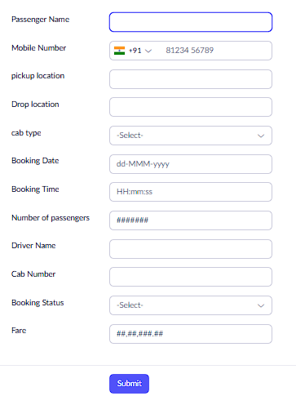

OUTPUT
